Dispatch No. 300 | 21 May 2019

Dispatch should focus on one key theme and fit on 8-14 pages (including charts). You may use this model as a template by replacing the text/charts and deleting these blue guidance boxes. For helpful Do’s and Don’ts that apply to all analysis and reporting, please see the R8 Survey Manual.

Core partner logo (P. 1 only)

NP logo (P. 1 only)

# **Ugandans support gender equality, but women political participation**

## **Afrobarometer Dispatch No. | Liberty Christopher**

**Summary (Acts as an introduction (with a few references), summary of findings (topline, no specific %s, and interpretation (what does it mean?)**

Women have a right to engage in their country’s political processes, vote in elections, be elected to government office, serve on boards, and participate in civic activities that will affect their lives, families, and their communities. Ensuring that girls and women participate in political activities in their country is a necessary step to achieving the United Nations’ (2019) Sustainable Development Goal No. 5: “Achieve gender equality and empower all women and girls.”

In Uganda, government efforts to promote gender equality include a National Gender Policy (2007), a Gender and Equity Strategy for Social Protection (2018), and a variety of program interventions emphasizing women’s empowerment, such as the Uganda Women Entrepreneurship Programme, Labour Works Program, and Youth Livelihood Program (Uganda Bureau of Statistics, 2019).

But despite notable efforts, women still lag behind men in access to political and socio-economic opportunities. Women remain vulnerable to gender-based violence, own fewer assets than men, have less representation in parliament, and are less likely than men to have paid employment (Uganda Bureau of Statistics, 2017a, 2017b, 2019; Gabola et al., 2018; Wyrod, 2008).

According to the latest Afrobarometer survey, most Ugandans support gender equality and majority of Ugandans say equal opportunities and treatment for women have improved in recent years. A majority think that omen should have the same chance of being elected to political office as men. (Afrobarometer R7). But what

However, women are still marginalized in politics and their participation has not been brought to the fore. Women are not only underrepresented in the political sphere but are sometimes prohibited from participating in active elective politics.

**Afrobarometer surveys**

Afrobarometer directs a pan-African, nonpartisan research network that conducts public attitude surveys on democracy, governance, economic conditions, and related issues in African countries. Seven rounds of surveys were completed in up to 38 countries between 1999 and 2018. Round 8 surveys in 2019/2020 are planned in at least 35 countries. Afrobarometer conducts face-to-face interviews in the language of the respondent’s choice with nationally representative samples.

The Afrobarometer team in [country], led by [NP], interviewed [1,200/2,400] adult [citizens of this country] in [month year]. A sample of this size yields country-level results with a margin of error of +/-3 [or +/-2] percentage points at a 95% confidence level. Previous surveys were conducted in [country] in [years].

Avoid footnotes in dispatches.

**Key findings**

* A considerably high percentage of women (39%) responded that they would never discuss political matters when they are either with their friends or family members

3-5 key findings. Your most important, newsiest findings. Concise. Should progress logically, like a story.

* The majority of Ugandans believe that women should have an equivalent chance of being elected to political office as men
* 76% of respondents say women should have an equal chance as men of being elected to political office
* More Males would occasionally discuss political matters once they get together with their friends or family compared to Females
* 63% of Ugandans say that equal opportunities and treatment of women is better than it was a few years ago
* A sizeable portion of women of say they have never got news from the radio (20%)

**Political leadership for women in Uganda**

A majority of Ugandans gender equality, but some respondents think that men make better leaders than women. A high percentage (76%) of respondents say women should have the same chance as men of being elected to political office. Less than a quarter of Ugandans (22%) think men make better political leaders than women and should be elected in their place

Short sections highlight major themes, with headlines that clearly summarize the point that your audience should focus on. Each section contains specific findings (%) and refers to charts/figures.

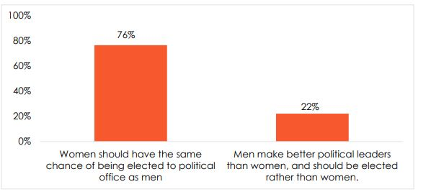Respondents were asked: Which of the following statements is closest to your view? (% who “agree” or “agree very strongly” with each statement)

**Figure 1: Support for gender equality in politics** | Uganda | 2016-2018

**Men as leaders v women as leaders**

Many of the respondents think that women should have the same chance of being elected to political office as men even though more respondents in the urban areas agree very strongly (63%) compared to 60% in rural areas that women have the same chance as men.

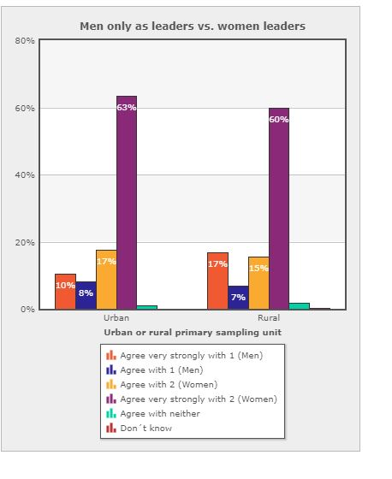

Provide exact text of the question.

Make sure it is clear which responses or categories are being reported, either in a legend in the chart or in a note below the chart.

Use a variety of types of graphs (see various examples).

Make your charts in AB Excel chart template and paste it into your dispatch. Always submit Excel document along with your Word document.

***Respondents were asked:*** *Men only as leaders vs. women leaders*

*Statement 1: Men make better political leaders than women, and should be elected rather than women. Statement 2: Women should have the same chance of being elected to political office as men.*

**Figure 2: Men only as leaders vs. women leaders** | Uganda | 2016-2018

**Handling promoting equal rights/opportunities for women**

**About 8% have noted a fall off in Ugandan government’s promotion of opportunities and equality for women. In contrast, 26% of Uganda believe that Uganda has recorded an improvement in availing equal tights and opportunities for women. Better still, six out of ten respondents say Uganda’s efforts to promote gender equality have stayed the same Overall, Ugandan citizens perceive that Uganda’s support for equal rights, gender equality and promoting opportunities for women has stayed the same between 2016 - 2018.**

**How well or badly would you say the current government is handling the following matters, or haven’t you heard enough to say? Promoting opportunities and equality for women**

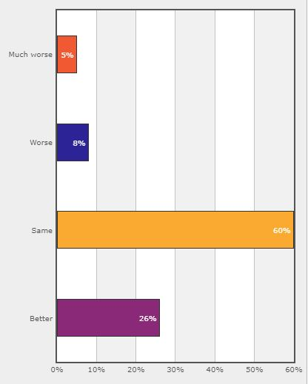

**Equal opportunities and treatment for women**

Afrobarometer also sought to know whether things are worse or better now than they were a few years ago, or whether they about the same concerning equal opportunities and treatment for women. About one in 20 or fewer say things are worse concerning equal opportunities and treatment of women (6%), whereas slightly more than a quarter of the respondent (17%) think provision of equal opportuities and treatment for women have become so much better than they were before. The highest percentage of the respndents say equal opportunities adn treatment of women is better than it was a few years ago (63%)

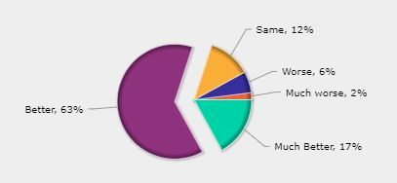

**Figure 3: Better or worse: equal opportunities and treatment for women**

*Respondents were asked: Please tell me if the following things are worse or better now than they were a few years ago, or are they about the same? Equal opportunities and treatment for women*

**Discussing politics**

When it comes to discussing issues that pertain to politics, Men are more engaged compared to women because 55% of male respondents say they when they get together with their friends or family, they would you that they occasionally discuss political matters. A high percentage of women (39%) responded that they would never discuss political matters when they are either with their friends or family members. More than a quarter, 20% of male respondents tend to discuss political matters frequently way more than women.

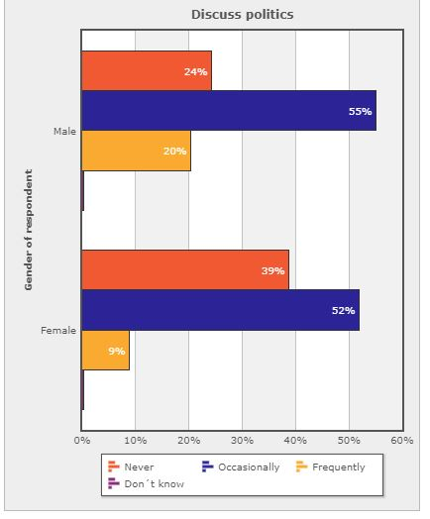

***Respondents were asked:*** *Discuss politics*

*When you get together with your friends or family, would you say you discuss political matters.*

**Figure 4: Discuss Politics** | Uganda | 2016-2018

**Information access**

According to Uganda Communication Commissions, listenership figures show that radio is the most popular medium in Uganda. With regard to information access, more than three-fifths of Ugandan men (61%) say they get news from the radio everyday. On the other hand, only four in ten (43%) of women say they get news from radio daily with about 20% of women stating they have never got news from the radio. (Figure 3).

**Figure 5: How often do you get news from the following sources? Radio** | Uganda | 2016-2018

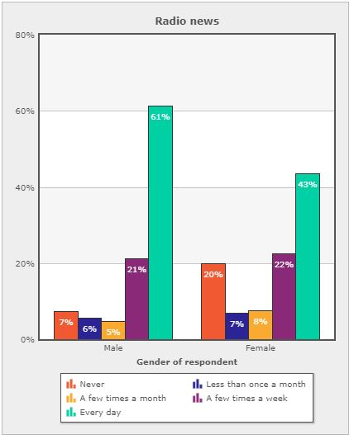

Use substantive legends that make it clear what the chart is about. Do NOT use “Agree with Statement 1,” etc.

***Respondents were asked****: How often do you get news from the following sources? Radio*

**Figure 6: Perceived personal safety compared to a few years ago** | Tunisia | 2018

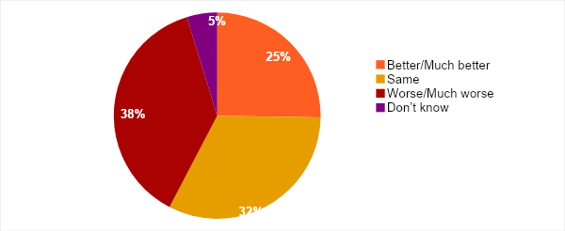

Use pie charts sparingly.

Don’t use them if there are too many response categories or if all categories don’t add up to exactly 100%.

***Respondents were asked:*** *Please tell me if the following things are worse or better now than they were a few years ago, or are they about the same: Your personal safety from crime and violence?*

Afrobarometer also sought to know whether Tunisians had experienced or feared violence in various settings. About one in 20 or fewer say they experienced violence among people in their neighbourhood (6%), during a political rally (4%), during public protests or marches (4%), or in attacks by political or religious extremists (2%). About three in 10 (30%-32%) say they feared (but didn’t experience) violence in each of these settings (Figure 5).

**Figure 5: Feared or experienced violence in the past two years** | Tunisia | 2018

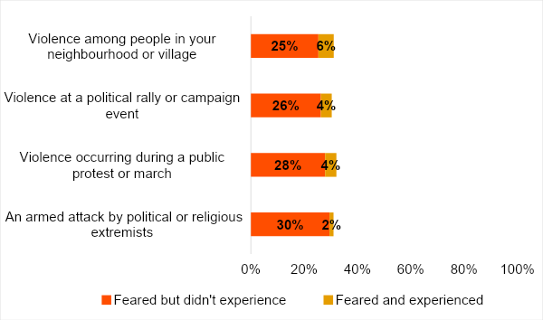

***Respondents were asked:*** *Please tell me whether, in the past two years, you have ever personally feared any of the following types of violence? [If yes:] Have you actually personally experienced this type of violence in the past two years?*

**State performance on security**

Only one-third (32%) of Tunisians say the government is performing “fairly well” or “very well” in reducing crime (Figure 6). Six in 10 (61%) describe the government’s performance as “fairly” or “very” bad, although this is an improvement from 2013 (73%).

However, seven in 10 Tunisians (71%) think it is “somewhat likely” or “very likely” that the police will take action when they report crime (Figure 7).

**Figure 6: Government performance in reducing crime** | Tunisia | 2013-2018

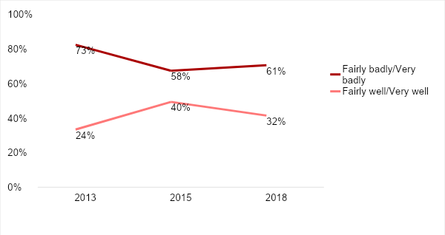

***Respondents were asked:*** *How well or badly would you say the current government is handling the following matters, or haven’t you heard enough to say: Reducing crime?*

**Figure 7: Police responsiveness to reported crime** | Tunisia | 2018

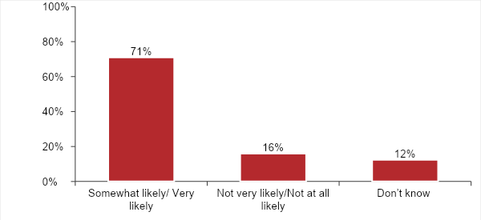

***Respondents were asked:*** *How likely is it that you could get someone to take action if you went to a government office or other public institution to report the following problems, or haven’t you heard enough to say: If you went to the local police to report a crime?*

Citizens give the military high marks for its performance in ensuring the security of the country. More than eight in 10 (83%) say the armed forces “often” or “always” keep the country safe from external and internal security threats, and more than three-fourths (78%) say they “often” or “always” act professionally and respect the rights of all citizens. But a far smaller majority (57%) of citizens say the armed forces “often” or “always” get the training and equipment they need to be effective (Figure 8).

**Figure 8: Perceptions of the armed forces** | Tunisia | 2018

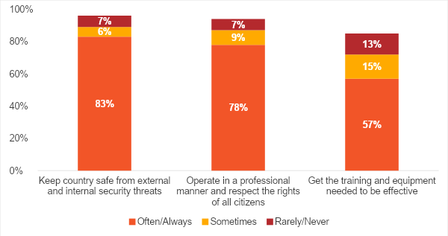

***Respondents were asked:*** *In your opinion, to what extent do the armed forces of our country:*

*Keep our country safe from external and internal security threats?*

*Operate in a professional manner and respect the rights of all citizens?*

*Get the training and equipment needed to be effective?*

**Do Tunisians accept less freedom in the name of security?**

Even if citizens’ concerns about security have decreased somewhat compared to 2015, a majority of Tunisians appear willing to accept some limitations on personal freedoms in exchange for public security (Figure 9). More than three-fourths (79%) of respondents say that if public security is threatened, the government should be able to impose curfews and set up special roadblocks to prevent people from moving around. Similarly, 74%[1] “agree” or “agree very strongly” that the government should have the right to regulate what is said in places of worship if public security is at risk.

Support for government monitoring of private communications is much less strong, but still, a majority (53%) say it should be able to monitor mobile phones and other communications to make sure that people are not plotting violence.

**Figure 9: Freedom vs. security** | Tunisia | 2018

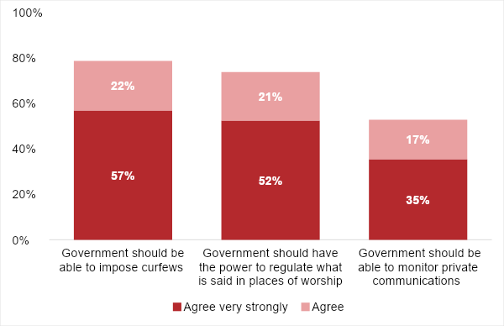

***Respondents were asked****:*

*Which of the following statements is closest to your view?*

*Statement 1: Even if faced with threats to public security, people should be free to move about the country at any time of day or night.*

*Statement 2: When faced with threats to public security, the government should be able to impose curfews and set up special roadblocks to prevent people from moving around.*

*Which of the following statements is closest to your view?*

*Statement 1: Freedom of religion and worship are absolute, meaning that government should never limit what is said in a place of worship.*

*Statement 2: Government should have the power to regulate what is said in places of worship, especially if preachers or congregants threaten public security.*

*Which of the following statements is closest to your view?.*

*Statement 1: Government should be able to monitor private communications, for example on mobile phones, to make sure that people are not plotting violence.*

*Statement 2: People should have the right to communicate in private without a government agency reading or listening to what they are saying.*

**Best way to deal with Tunisians who fought with ISIL**

In 2017, an estimated 6,000 Tunisians left the country to join the Islamic State (ISIL) (Bremmer, 2017). As the terrorist group crumbled, many returned home, and are seen as a potential security risk (Meko, 2018; Mintner, 2019). When asked how the government should deal with these returned fighters, almost two-thirds of Tunisians say they should face legal consequences, ranging from being tried in court (34%) or being jailed (11%) to being executed (20%). About one in four respondents (27%) say they should be rehabilitated, while only 3% say they should be “left alone” (Figure 10).

**Figure 10: How should government deal with Tunisians who fought with ISIL?**

| Tunisia | 2018

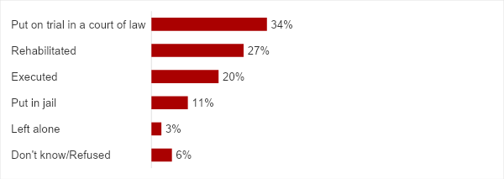

**Respondents were asked: In your opinion, how should our government deal with Tunisians who return to the country after fighting alongside Islamic State (ISIL)?**

Brief conclusion should summarize and highlight implications or possible uses of the main findings. Don’t just repeat all the findings.

**Conclusion**

The most recent Afrobarometer survey suggests that Tunisians are less concerned about security now than they were in the violent year of 2015. Still, the issue of crime and security remains high among citizens’ priority problems, and only a quarter of Tunisians think their personal safety has improved. However, most Tunisians give the military high marks on protecting the country, and most would accept limitations on their freedom of movement, their right to private communication, and their religious liberty to help ensure public safety.

For policy makers and civil society, these findings point to a need for strategies to increase citizens’ feeling of personal safety without requiring them to sacrifice personal freedoms.

Do your own analysis of Afrobarometer data – on any question, for any country and survey round. It’s easy and free at www.afrobarometer.org/online-data-analysis.

**References**

Al Jazeera. (2013).[Who killed Tunisia's Chokri Belaid?](https://www.aljazeera.com/indepth/features/2013/09/201394183325728267.html) 12 September..

Use American Psychological Association style (follow examples shown here).

Wherever possible, provide a link (make the title a link, not as a separate URL).

Arab Weekly. (2019). [Tunisian security forces stymie jihadists’ effort to forge new ‘emirate.’](https://thearabweekly.com/tunisian-security-forces-stymie-jihadists-effort-forge-new-emirate) 5 January..

BBC News. (2017). [Tunisia profile – timeline. A chronology of key events](https://www.bbc.com/news/world-africa-14107720). 1 November..

BBC News. (2018). Tunis attack: Woman blows herself up in Tunisia. <https://www.bbc.com/news/world-africa-46017905>.

Bremmer, I. (2017). [The top 5 countries where ISIS gets its foreign recruits](http://time.com/4739488/isis-iraq-syria-tunisia-saudi-arabia-russia/). 14 April.

Meko, T. (2018). [Now that the Islamic State has fallen in Iraq and Syria, where are all its fighters going?](https://www.washingtonpost.com/graphics/2018/world/isis-returning-fighters/) Washington Post..

Middle East Monitor. (2019a). [Tunisia protests against ‘government policies.’](https://www.middleeastmonitor.com/20190405-tunisia-protests-against-government-policies/) 5 April.

**[ Author’s Name ]** is [title] for [organisation] in [location]. Email: [address].

**[ Author’s Name ]** is [title] for [organisation] in [location]. Email: [address].

Afrobarometer, a nonprofit corporation with headquarters in Ghana, directs a pan-African, non-partisan research network. Regional coordination of national partners in about 35 countries is provided by the Ghana Center for Democratic Development (CDD-Ghana), the Institute for Justice and Reconciliation (IJR) in South Africa, and the Institute for Development Studies (IDS) at the University of Nairobi in Kenya. Michigan State University (MSU) and the University of Cape Town (UCT) provide technical support to the network.

Financial support for Afrobarometer Round 8 has been provided by the Swedish International Development Cooperation Agency (SIDA), the Mo Ibrahim Foundation, the Open Society Foundations, the William and Flora Hewlett Foundation, and the U.S. Agency for International Development (USAID) via the U.S. Institute of Peace.

Donations help Afrobarometer give voice to African citizens. Please consider making a contribution (at www.afrobarometer.org) or contact Felix Biga (felixbiga@afrobarometer.org) to discuss institutional funding.

Follow our releases on #VoicesAfrica. Image result for facebook iconhttps://encrypted-tbn1.gstatic.com/images?q=tbn:ANd9GcQUwBmsPGtE8Tqai7o6FY29JyXi5cBkzJsNcelpuCahg35VxCL-2TaFNd_k6wImage result for twitter icon

/Afrobarometer @Afrobarometer

**Afrobarometer Dispatch No. X | XX Month 2017**

1. Due to rounding, percentages for combined categories may differ slightly from the sum of sub-categories (e.g. 52% “agree very strongly” and 21% “agree” combine to 74%).